MATH503 Week 5 Group Activity - Old Faithful
Student ID | Name | Signature
25288226 | Matthew Rushmer | Matthew Rushmer
25309839 | Nina Millado | create partition primary
This activity will be completed in pairs.
The activity is based on data for the time (in minutes) between eruptions for the Old Faithful geyser.
Enter your answers on the word file. Submit your completed activity via online submission. Only one submission per pair. Name your file using your AUT ids: MATH503_Week5_ID1_ID2.docx.
Stage 1
Write down your initial predictions for the waiting time to the next eruption when you have no data.
Student 1 prediction:
Student 2 prediction:
Stage 2
You will be given a day’s worth of data. Use the data to make an estimate of the waiting time. You may construct a graph or use summary statistics, but you must give some justification for your prediction.
On your word file record:
- Which day’s data you were given: 5
- Your estimate for the waiting time to the next eruption based on this data: 72 .17 minutes
- Copies of any graphs you constructed:
Min. 1st Qu. Median Mean 3rd Qu. Max.
50.00 63.00 76.50 72.17 81.00 87.00
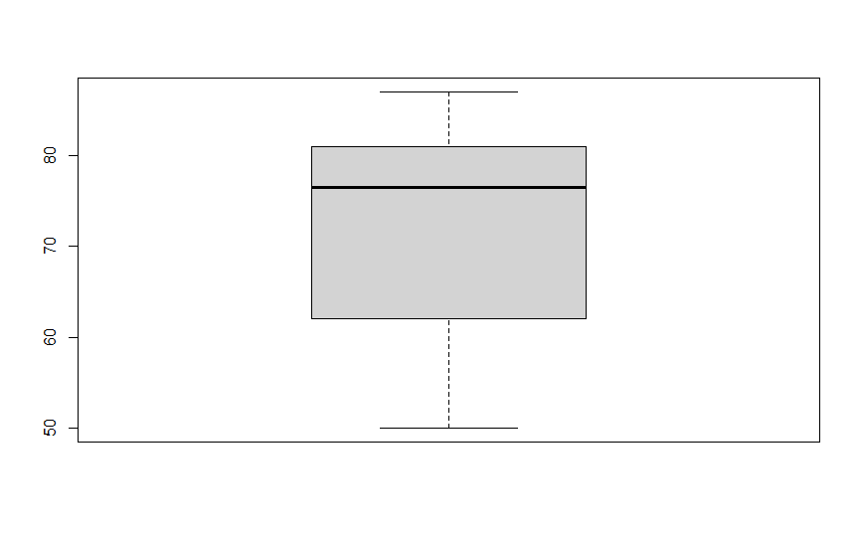
- Your justification(s) for your prediction: When looking at the next eruption we have to consider the rest of the time between eruptions. With this information we can produce a mean value. This value is an average of all the time we have in our data, therefore our best guess at the time to the next eruption. There is no other data which can give us any more information in our dataset right now.
Stage 3
Use the data for any other day and investigate this new day’s data to make another prediction. Compare the data for the separate days. How does your prediction compare with your previous one?
On your word file record:
- Comparisons between the datasets, both summary statistics and graphs constructed.
Day 5:
Min. 1st Qu. Median Mean 3rd Qu. Max.
50.00 63.00 76.50 72.17 81.00 87.00

Day 2:
Min. 1st Qu. Median Mean 3rd Qu. Max.
54.00 65.00 75.50 72.61 81.25 88.00
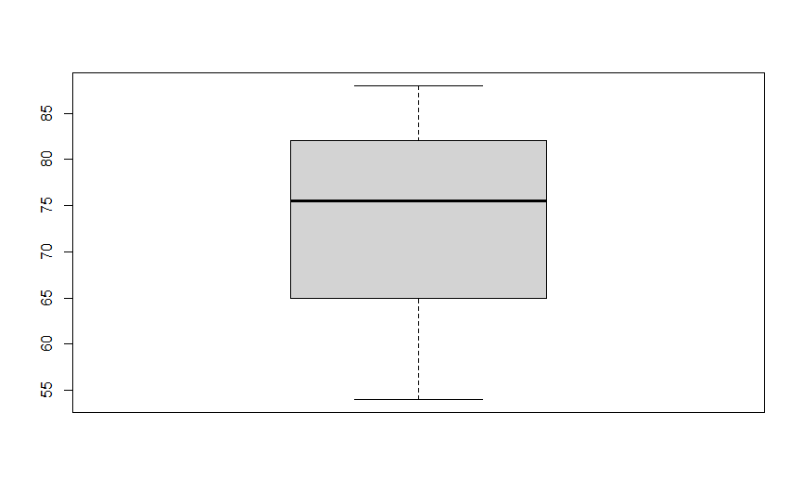

Both graph have a similar peak value but day 5 has a much low min value. They have a similar mean value. Day 2 has a much small UQ and a much larger LQ compared to day 5. The IQR of day 5 is 18 compared to day 2 which has a IQR of 16.25. Day 5 has a median of 76.5 and day 2 has a median of 75.5. Despite most of the value being different it mostly stay close. The data has not shift that much when comparing day 2 and day 5

- Your updated estimate for the waiting time to the next eruption based on two different days’ worth of data. 72.39
- Copies of any graphs you constructed.
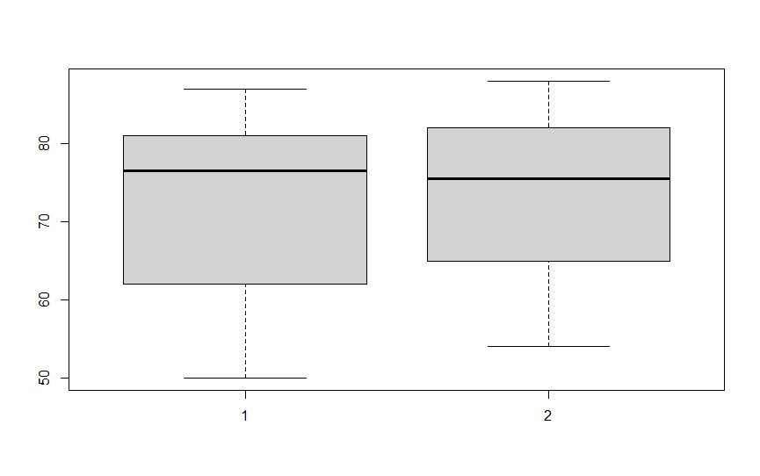
- Your justification(s) for your prediction. As we outlined in task 2 we used the mean value to estimate expect waiting time. So for this predication we Mayde an average of both means. This we believe give us our best possible prediction of the time between next eruption with the data we have.
- Write two sentences about any interesting insight you have discovered about the data.
We found it interesting how the max time between eruptions from day 2 to day 5 stayed the same, the min value shifter lower for day 5. We also were interested in the much larger LQ of day 5 compare to day 2 yet the mean values stay similar.

Stage 4
Share your predictions and graphs with another group who used different data.
On your word file record:
- The reasoning of the other group’s prediction
- In words comment on the graphs the other group used and what it revealed about the data.
- What can the following graphs reveal about the distribution of a dataset?
Stem and leaf
Box and whisker
Histogram
Time series

